Jared Fowler

Physics M20CL – Thursday 1pm

**Theory**

**Incident Ray**

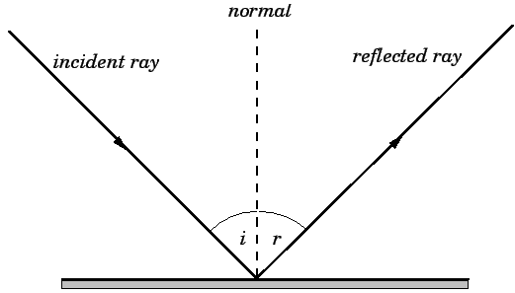A ray of light that strikes a surface. The angle between this ray and the perpendicular or normal to the surface is the angle of incidence. The reflected ray corresponding to a given incident ray, is the ray that represents the light reflected by the surface (Wikipedia).

**Law of Reflection**

The law of reflection governs the reflection of light-rays off smooth conducting surfaces, and states that the incident ray, the reflected ray, and the normal to the surface of the surface all lie in the same plane. Furthermore, the angle of reflection ‘r’ is equal to the angle of incidence ‘i’ (http://farside.ph.utexas.edu).

**Relationship Between Prism Apex Angle and Angles of Reflection**

A prism apex incident with a wide collimated beam of light will reflect half the beam from each face adjacent to the vertex. The angle between the two reflected beams, ‘z’ as seen in Figure 0.1, is twice the prism angle ‘A’.

**Proof:**

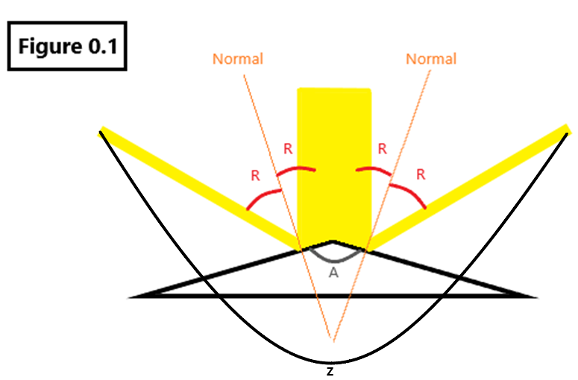By the Law of Reflection, the angle of incidence with respect to the normal is equal to the angle of reflection with respect to the normal.

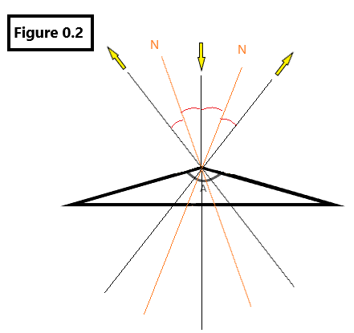

Modify the diagram by shifting all vertices to overlay the prism apex. Propagate the rays of incidence and reflection through the prism for reference, as seen in Figure 0.2.

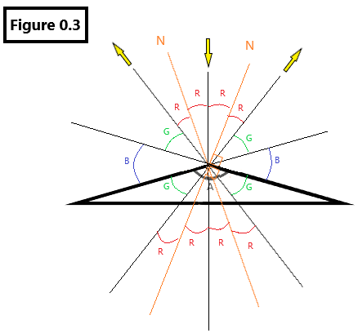Propagate the apex vectors for reference. Use the rule of vertical angles to label matching angles.

The following properties are gathered from Figure 0.3:

$$90°=3R+G$$

$$90°=R+G+B$$

This can only be true if $B=2R$. Therefore, the total angle between the two rays of reflection is:

$$4G+8R$$

And the apex angle is equal to:

$$2G+4R$$

Note that $2\left(A\right)=2\left(2G+4R\right)=4G+8R$. Therefore, the angle between the two reflected beams is twice the prism apex angle.

**Data and Analysis**

The angular difference of each side of the light beam as seen through the telescope was measured and taken as the absolute angle error. $δθ=δφ=0.42°=0.0073 rads$

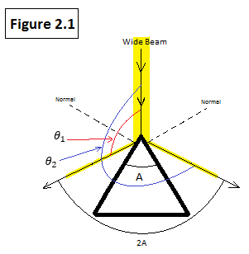Measured Values (referring to Figure 2.1):

$$θ_{1}=120.66°$$

$$θ_{2}=241.68°$$

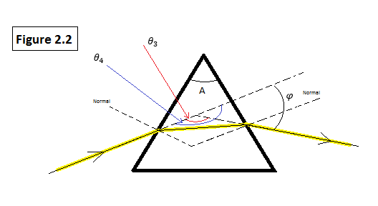

$$θ_{2}-θ_{1}=2A$$

$$A=\frac{θ_{2}-θ_{1}}{2}=\frac{241.68°-120.66°}{2}=60.51°$$

Measured Values (referring to Figure 2.2):

$$θ_{3}=133.25°$$

$$θ_{4}=181.50°$$

$$φ=θ_{4}-θ_{3}=181.50°-133.25°=48.25°$$

|  |  |  |
| --- | --- | --- |
| **Index of Refraction** | | |
| $$n=\left(\frac{\sin\left(\frac{φ+A}{2}\right)}{\sin\left(\frac{A}{2}\right)} \right)$$ |  | Theoretical Equation |
|  |  |  |
| $$n=\left(\frac{\sin\left(\frac{48.25°+60.51°}{2}\right)}{\sin\left(\frac{60.51°}{2}\right)} \right)=1.61$$ |  | Index of Refraction |

|  |  |  |
| --- | --- | --- |
| **Error Propagation – Index of Refraction with Minimum Angle of Deviation** | | |
| $$n=\left(\frac{\sin\left(\frac{φ+A}{2}\right)}{\sin\left(\frac{A}{2}\right)} \right)$$ |  | Theoretical Equation |
|  |  |  |
| $$\frac{∂n}{∂φ}=\left(\frac{\cos\left(\frac{φ+A}{2}\right)}{2\sin\left(\frac{A}{2}\right)}\right)$$ |  | Take partial derivative for $φ$ |
|  |  |  |
| $$n=\sin\left(\frac{φ+A}{2}\right)*\csc\left(\frac{A}{2}\right)$$ $$Product Rule:$$ $$\frac{d}{dx}\left(u,v\right)=v\frac{du}{dx}+u\frac{dv}{dx}$$ $$Where u=\csc\left(\frac{A}{2}\right) and v=\sin\left(\frac{φ+A}{2}\right)$$ $$\frac{∂n}{∂A}=\left(\sin\left(\frac{φ+A}{2}\right)*\left(-\frac{1}{2}\csc\left(\frac{A}{2}\right)\cot\left(\frac{A}{2}\right)\right)\right)+\left( \csc\left(\frac{A}{2}\right)*\left(\frac{1}{2}\cos\left(\frac{φ+A}{2}\right)\right)\right)$$ $$\frac{∂n}{∂A}=\frac{1}{2}\csc\left(\frac{A}{2}\right)\left( \cos\left(\frac{φ+A}{2}\right)-\sin\left(\frac{φ+A}{2}\right)\cot\left(\frac{A}{2}\right)\right)$$ |  | Take partial derivative for $A$.  Rewrite base equation.  Use product rule. |
|  |  |  |
| $$δn={\left\{{\left[δφ\left(\frac{∂n}{∂φ}\right)\right]}^{2}+{\left[δA\left(\frac{∂n}{∂A}\right)\right]}^{2}\right\}}^{\frac{1}{2}}$$ |  | Definition for absolute error. |
|  |  |  |
| $$\frac{δn}{n}={\left\{{\left[\frac{δφ\left(\frac{∂n}{∂φ}\right)}{n}\right]}^{2}+{\left[\frac{δA\left(\frac{∂n}{∂A}\right)}{n}\right]}^{2}\right\}}^{\frac{1}{2}}$$ |  | Definition for relative error. |
|  |  |  |
| $$\frac{δn}{n}={\left\{{\left[\frac{δφ\left(\frac{\cos\left(\frac{φ+A}{2}\right)}{2\sin\left(\frac{A}{2}\right)}\right)}{\left(\frac{\sin\left(\frac{φ+A}{2}\right)}{\sin\left(\frac{A}{2}\right)} \right)}\right]}^{2}+{\left[\frac{δA\left(\frac{1}{2}\csc\left(\frac{A}{2}\right)\left( \cos\left(\frac{φ+A}{2}\right)-\sin\left(\frac{φ+A}{2}\right)\cot\left(\frac{A}{2}\right)\right)\right)}{\left(\frac{\sin\left(\frac{φ+A}{2}\right)}{\sin\left(\frac{A}{2}\right)} \right)}\right]}^{2}\right\}}^{\frac{1}{2}}$$ |  | Substitute |
|  |  |  |
| $$\frac{δn}{n}={\left\{{\left[\frac{δφ\cot\left(\frac{φ+A}{2}\right) }{2}\right]}^{2}+{\left[\frac{δA\left(\cot\left(\frac{φ+A}{2}\right)-\cot\left(\frac{A}{2}\right)\right)}{2}\right]}^{2}\right\}}^{\frac{1}{2}}$$ |  | Simplify |
|  |  |  |
|  | | |

|  |  |  |
| --- | --- | --- |
| **Percent Discrepancies** | | |
|  |  | Definition of percent discrepancy. |
|  |  |  |
|  |  | Apex Angle of Prism (Theoretical: ) |
|  |  | Index of Refraction (Theoretical: 1.60) |

**Conclusion**

The experiments yielded favorable results consistent with the glass prism’s theoretical apex angle ($60°$) and index of refraction (**1.60**). The apex angle was experimentally found to be $60.51°± 1\%$ and the index of refraction, calculated with the experimentally found apex angle and minimum angle of deviation, was found to be $1.61±1\%$. The percent discrepancies of these results are both **1%**, which is equal to the allowed margins of error.

The margins of error were found using an error propagation technique. The absolute error ($δθ=0.42°$) for all measured angles was taken as the angular difference measured on the spectrometer from one vertical edge of the light beam to the other (beam’s width).

While error-prone human observation was present in the experiment, the spectrometer provided very precise measurements and the absolute angular error was relatively small compared to the measured angles. Perhaps the most erroneous part of the experiment was attempting to observe the minimum angle of deviation while rotating the prism. Regardless, the absolute angular error sufficiently accounted for this observational error.

The experiment could be improved by having a precise theoretical value for the prism’s index of refraction, as the value given in lab was only an astute estimation.